Step 4: Design Instructional Programs

Types of Reponses

Discrete | Chained
- A single behavior demonstrated by the student.  - Does not produce a functional outcome in and of itself.  - Examples:  Naming numerals  Picking up an object  Decoding vowels  Imitating a sound | - Requires the student to perform several behaviors in a specific sequence.  - May or may not produce a functional outcome for the student.  - Examples:  Shopping for groceries  Rote counting  Washing dishes

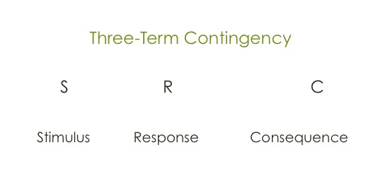
Components of the Instructional Program

- Objective (Describe goal for acquisition or generalization of skill)
  - Acquisition
    - Discrimination Training (establish when to perform the skill and when not to)
    - Response Training (develop new response or shape an existing response)
  - Generalization
    - Completes behavior even with variations in the stimuli (drinking from cup, mug, glass)
    - Adjusts the response as necessary to accommodate different stimuli (crossing the road at a light, stop sign, cross walk)
- Concept Analysis
- Phases (Response Prompting and Fading Procedures)
  - Purpose:
    - Highlight the positive example and/or relevant dimension of the discriminative stimulus during instruction
    - Increase the efficiency of instruction by minimizing student errors
    - Make instruction more positive for the student

  - Types (most-to-least):
    - Pictorial or graphic prompts: Written directions, pictures, symbols, numerals, etc.
    - Physical Assistance: Hand over hand assistance from the teacher to complete the target response
    - Physical prime: Brief physical contact between the teacher and the student used to “prime” the student’s correct response
    - Model: A demonstration of the correct response by the teacher. Students are expected to “imitate” the teacher’s behavior
    - Gestures: Physical movements by the teacher such as points and head nods. Designed to indicate the expected response to the student.
    - Direct verbal prompt: Spoken directions given by the teacher about the expected response. Structure to provide “clear” and “precise” instructions.
    - Indirect verbal prompt: Spoken directions provided by the teacher that indicate that a response is expected intended to get the student to initiate the response but not to specify the expected response.
    - Independent: Student is expected to perform the task without teacher assistance. Relies on natural stimuli to initiate the behavior.

  - Fading:
    - Begin where baseline data indicates the student can perform the skill successfully.
    - Students can become “dependent” on prompts so they must be “faded.”
    - Fading is intended to “transfer” control of the student’s response from the teacher’s prompt to the discriminative stimulus.
    - Use time delay procedures:
      - Progressive (time increases between prompt and assistance)
      - Constant (time remains constant)

4. Steps (Instructional Sequence)

Sequencing Strategies
Skill | Concurrent | Cumulative
“Point to (letter)” | d, b, p, q, l – would be presented randomly across trials. | 1 d 4 l  2 p 5 d, p, or l  3 d or p etc.
“Touch (bill)” | $1, $5, $10, $20 presented randomly across trials. | 1. $1 4. $20  2. $5 5. $1, $5, or $20  3. $1 or $5 6. $10  7. $1, $5, $10, or $20

- Error Correction

If possible, the error response should be blocked.
- If the response can not be blocked, the student should be provided immediate feedback that an incorrect response has occurred. This can be done by saying “No.”
- The target stimulus should be re-presented to the student. This can be accomplished by repeating the cue used to initiate the trial.
- Provide the level of assistance necessary to ensure a correct response. This can be accomplished by backing up to the previous level of assistance in the response prompting and fading procedure.
- The student should be provided feedback about the correct response. Feedback should be encouraging but low key

- Reinforcement

Differential Reinforcement
  - Use natural reinforcers (social or activity). This should ALWAYS be age-appropriate and avoid food reinforcers.
  - Use a continuous schedule during initial stages of acquisition.
  - Move to an intermittent schedule as soon as possible.

